**VISUAL PROGRAMMING PROJECT**

**PROJECT PROTOTYPE/ INTERFACE**

**11-APRIL-16**

**MAHNOOR AHMED**

**01-133132-121**

**BSE-6A**

A rough sketch of my project interface is shown below:

1. Login form

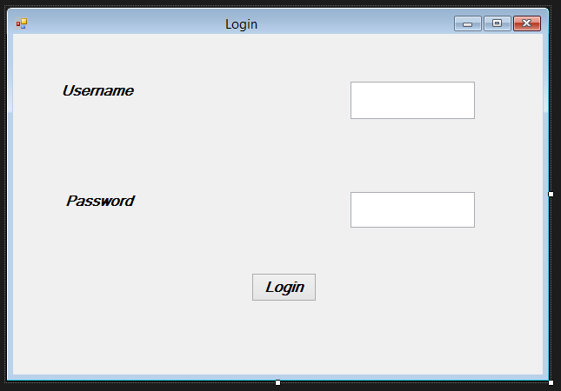

1. Simulator form

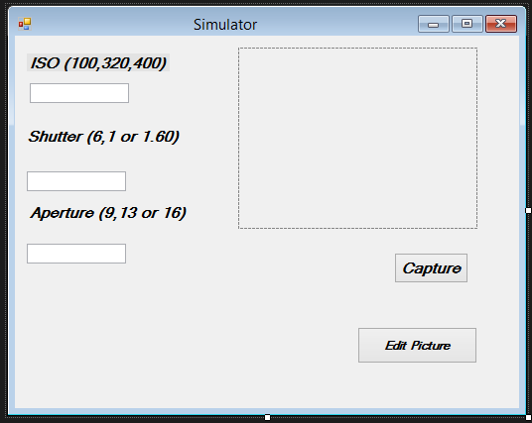

1. Editor form (more effects can also be added)

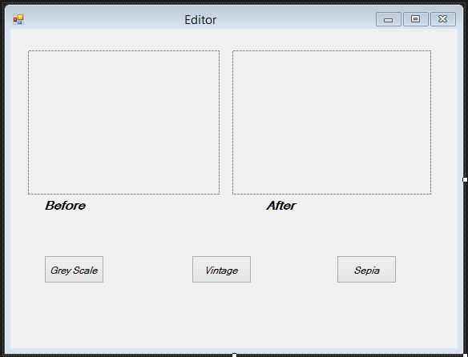

1. Image process form (removal of space between pixels)

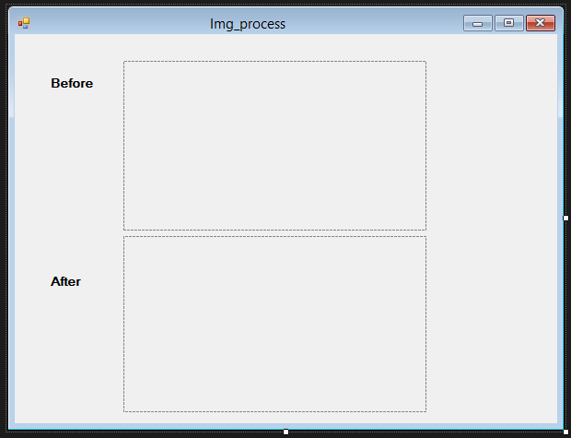

1. Contact/feedback form

